

# **First year establishment and baseline monitoring of planted seed islands, Waikereru Ecosanctuary, Tairāwhiti**

**Michael Bergin and David Bergin**

**October 2022**

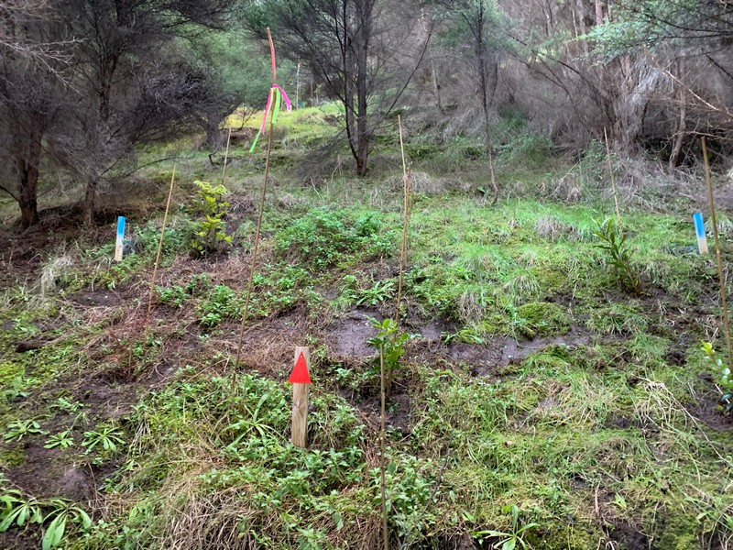

A planted gap within the existing scrub vegetation at Waikereru Ecosanctuary, Tairāwhiti

## **Introduction**

Seed islands comprising planted native trees and shrub species were established in mid-2022 as part of a 3-year project to demonstrate how to speed up succession of kānuka scrub into a diverse native forest on steep marginal former pastoral hill country in the Tairāwhiti region. This demonstration area was established in collaboration with The Longbush Ecological Trust at the Waikereru Ecosanctuary where over 100 ha of mostly regenerating hill country is located adjacent to the Longbush Reserve in the Waimatā River valley approximately 9 km north of Gisborne.

This report provides a brief description of the establishment of the first year of seed islands at the Waikereru Ecosanctuary including baseline measurement of planted native trees and shrubs and plans for ongoing monitoring and maintenance. Refer to the workplan for further details on the establishment of seed islands (Bergin and Bergin 2021), and to a report on evaluation of species and proposed location of sites for seed islands at Waikereru (Bergin and Bergin 2022).

The project is funded by the Lotteries Board with support from owners Anne and Jeremy Salmond, Trees That Count, research associates from Manaaki Whenua, NZ Landcare Trust, and Waimata River restoration landcare group. Nursery seedlings for the seed island are funded by Trees That Count (TTC). The planting site at Waikeruru Ecosanctuary has been registered as a TTC planting site and sample plots established to monitor early performance.

## **Other related work**

A botanical survey and mapping of mapping of the landforms of the Waikereru Ecosanctuary was completed in early 2022 to provide a context for monitoring natural regeneration and the establishment of a network of seed islands. Other work includes ongoing pest animal (both browsers and bird predators) and selective weed control as necessary to support the regeneration of the Waikereru Hills. The aim is to share the findings of this work with the wider community through workshops associated with the Waimatā River restoration project and the Wildlab/Tiaki Taiao wilderness education programme at Waikereru.

The landform mapping report by Marden and Seymour (2022) produced a GIS-based map of landform units present at Waikereru Sanctuary and the botanical survey was undertaken by Marley Ford supervised by Mark Smale.

## **Location of seed islands**

The lower slopes along the base of the steep hill country of Waikereru was inspected with Mike Marden and Jeremy Salmond, specifically above the pa-harakeke garden and older native tree plantations scoping the various sites within the existing kanuka to identify sites for the planting of seed island plots.

The aim was to locate seed islands on the lower slopes where there was the better soils, moisture retention and shelter from regenerating kanuka to maximise performance of planted natives compared to the upper slope land use classes. The sites for all seed islands were therefore located on alluvial fans as mapped and described by Marden and Seymour (2022) as follows:

***Alluvial fan.*** *Sloping landscape units located at the base of steep slopes and representing zones of accumulation of material displaced by slumping and shallow landslides from steeper slopes above. Fan material consists of thoroughly mixed forest soil, tephra, but predominantly comprise angular clasts of bedrock. Fans often display stratification that represents multiple episodes of landsliding and deposition of coarse-grained material at times of heavy rainfall during past storm events, separated by intervals of soil formation and accumulation of airfall tephra. With the retention of soil moisture for longer periods after rainfall, alluvial fans tend to more fertile than the landslide-scarred slopes from which the fan material originated. Most of the better-preserved alluvial fans have accumulated on alluvial terraces at the base of slopes flanking the true right bank of the Waimata River. Over time, the toe slopes of several of the older fans (i.e., those closest to the base of the hillside), and of younger alluvial fans emanating from the side tributaries draining the ecosanctuary, have been truncated as the Waimata River incised in response to tectonic uplift.*

The alluvial fan mapping unit which was used for locating all seed islands is shown in pink in Figure 1 from Marden and Seymour (2022).

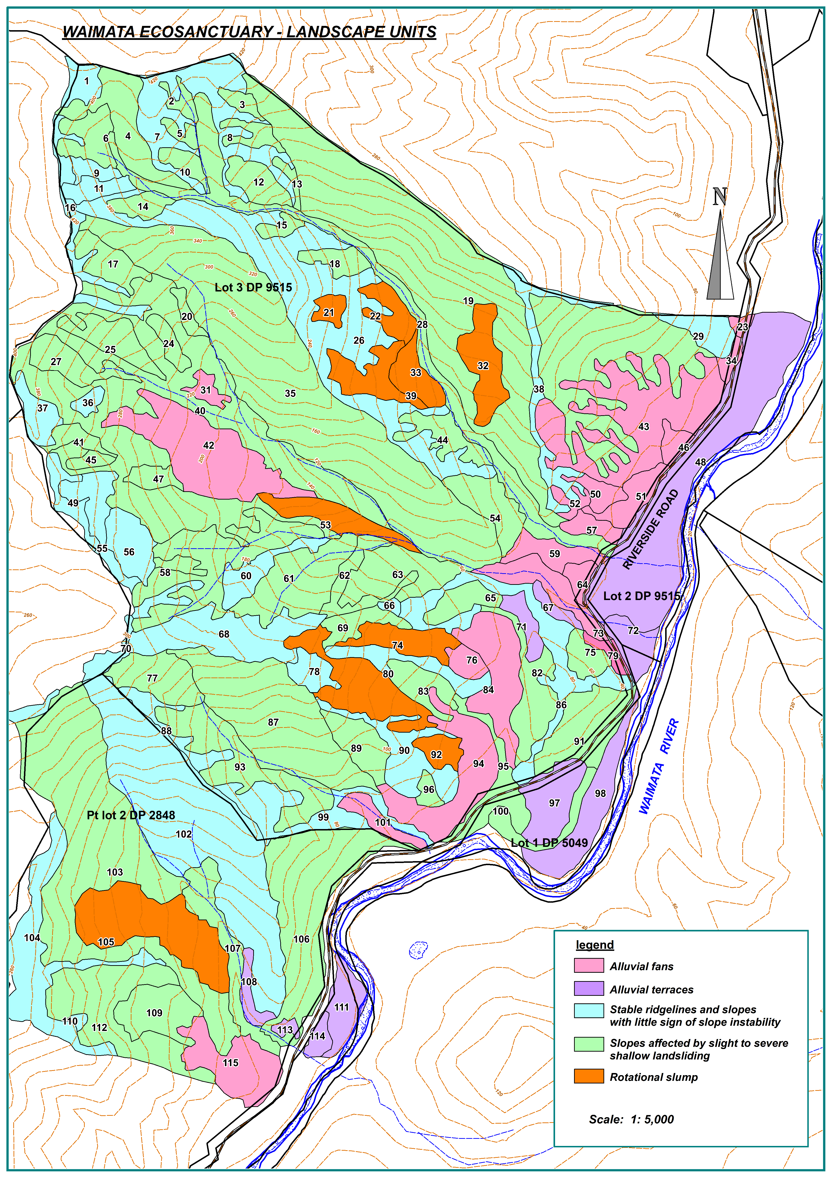

Figure 1: Landform mapping of Waikereru Ecosanctuary undertaken by Marden and Seymour (2022). Land Use Capability (LUC) class is provided together with contours and parcel boundaries based on an aerial view of the ecosanctuary flown in 2017. Descriptors for the LUC units are provided in Marden and Seymour (2022). The seed islands were all located on the alluvial fans LUC unit shown in pink, typically lower slopes of the steep hill country with higher fertility soils and good moisture retention compared to upper slope classes.

Potential seed island sites were identified based on the degree of shade and shelter into one of two broad shade categories – open canopy gaps with full overhead blue sky, and partial shade gaps with some degree of light canopy cover from the existing naturally regenerating kanuka. Twenty seed island sites were located for the first-year planting as shown in Figure 2. GPS location of the centre of each seed island along with shade category and approximate location within the alluvial fan LUC is indicated for each of the 20 seed islands in Table 2.

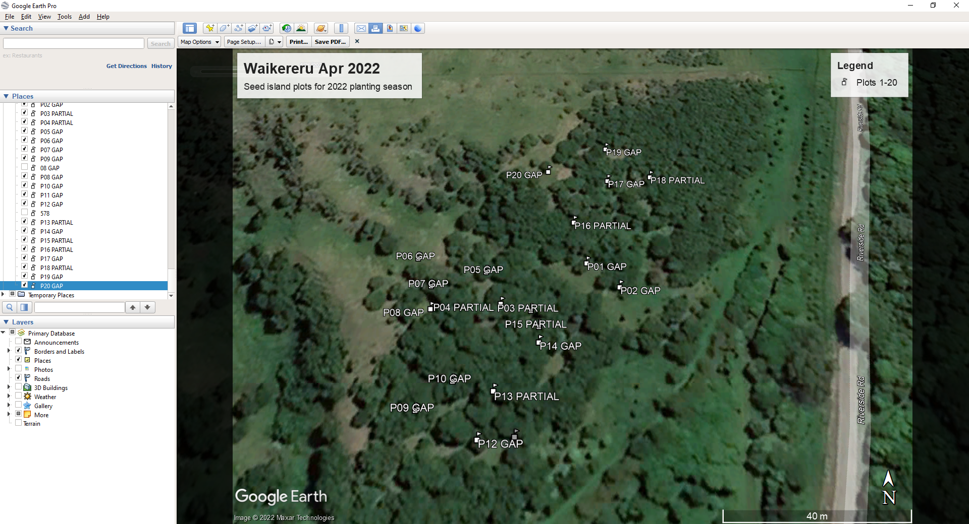

Figure 2: Map of the plot locations at Waikereru Ecosanctuary.

Table 1: Location of the 20 seed island plots established in the first year with the latitude and longitude of the plot centre, gap category based on degree of canopy shading and the approximate location within the alluvial fan slope Land Use Class (LUC).

|  |  |  |  |  |
| --- | --- | --- | --- | --- |
| **Plot no.** | **Latitude** | **Longitude** | **Shade category for each seed island** | **Location within alluvial fan LUC** |
| P01 | -38.606350° | 178.062364° | Open gap | Mid |
| P02 | -38.606414° | 178.062459° | Open gap | Lower |
| P03 | -38.606474° | 178.062204° | Partial shade | Mid |
| P04 | -38.606457° | 178.062117° | Partial shade | Mid |
| P05 | -38.606374° | 178.062069° | Open gap | Upper |
| P06 | -38.606337° | 178.061864° | Open gap | Upper |
| P07 | -38.606411° | 178.061912° | Open gap | Upper |
| P08 | -38.606470° | 178.061918° | Open gap | Upper |
| P09 | -38.606706° | 178.061909° | Open gap | Mid |
| P10 | -38.606642° | 178.062000° | Open gap | Mid |
| P11 | -38.606762° | 178.062173° | Open gap | Lower |
| P12 | -38.606768° | 178.062077° | Open gap | Lower |
| P13 | -38.606664° | 178.062111° | Partial shade | Lower |
| P14 | -38.606552° | 178.062229° | Open gap | Lower |
| P15 | -38.606514° | 178.062228° | Partial shade | Mid |
| P16 | -38.606235° | 178.062326° | Partial shade | Mid |
| P17 | -38.606109° | 178.062433° | Open gap | Mid |
| P18 | -38.606097° | 178.062569° | Partial shade | Mid |
| P19 | -38.606006° | 178.062430° | Open gap | Upper |
| P20 | -38.606080° | 178.062244° | Open gap | Upper |

## **Planting seed islands**

Prior to planting Steve Sawyer and the Ecoworks team laid out the plots marking the plot centres and corners and recorded the vegetation cover and other characteristics of each seed island site (Ecoworks New Zealand 2022). Planting was then undertaken by Ecoworks in May-June 2022 over several days.

Seedlings supplied by the Native Plant Nursery comprising 500 native tree and shrub species listed in Table 2. Species were randomly allocated across the 20 seed islands but ensuring all seed islands had a sample of all species.

Table 2: Native shrub and tree species planted in seed island in the first year at Waikereru Ecosanctuary.

|  |  |  |  |  |
| --- | --- | --- | --- | --- |
|  | **Species** |  | **Total plant order for Year 1** | **Average plants per plot** |
| **Shrubs/small trees** | |  |  |  |
|  | ngaio | *Myoporum laetum* | 30 | 3 |
|  | fivefinger | *Pseudopanax arboreus* | 20 | 2 |
|  | karamu | *Coprosma robusta* | 20 | 2 |
|  | kohuhu | *Pittosporum tenuifolium* | 20 | 2 |
|  | Wharangi | *Melicope ternata* | 20 | 2 |
|  | lacebark | *Hoheria populnea* | 20 | 2 |
|  | wineberry | *Aristotelia serrata* | 20 | 2 |
| **Trees** |  |  |  |  |
|  | kowhai | *Sophora tetraptera* | 50 | 5 |
|  | rewarewa | *Knightia excelsa* | 50 | 5 |
|  | titoki | *Alectryon excelsus* | 50 | 5 |
|  | puriri | *Vitex lucens* | 60 | 6 |
|  | totara | *Podocarpus totara* | 60 | 6 |
|  | kahikatea | *Dacrycarpus dacrydioides* | 50 | 5 |
|  | tanekaha | *Phyllocladus trichomanoides* | 20 | 2 |
|  | northern rata | *Metrosideros robusta* | 20 | 2 |
|  | black beech | *Nothofagus solandri var. solandri* | 30 | 3 |
|  | kohekohe | *Dysoxylum spectabile* | 20 | 2 |
| **TOTAL** |  |  | **500** | **50** |

Seedlings were laid out in a square plot with a centre peg and four corner pegs. The centre peg has a red plastic triangle marker attached to it. The four corner pegs of each plot are painted blue. All seedlings have a bamboo stake beside each seedling to help identify its location and to indicate that it is planted. The stake was not used to physically support the seedling, rather to allow quick relocation during post-planting maintenance and monitoring.

## **Baseline monitoring**

Monitoring of each of the seed islands is following the plot based methods used by Tāne’s Tree Trust and Trees That Count (Bergin, Sallis, Kimberley, Bergin 2022). For the baseline survey undertaken within one month of planting this has involved recording:

* Species planted
* Plant height
* Plant vigour using a subjective visual assessment score of 1-5:
  1. poor - few or no leaves, just alive
  2. unthrifty - loss of leaves, severe frosting damage or browsing, poor foliage colour
  3. average - moderate health and vigour
  4. good - minor browsing, frosting damage, etc…, otherwise good growth
  5. excellent - healthy plant with good foliage colour and growth

The level of overhead cover was assessed for each seedling based on the presence of existing vegetation canopy directly over each planted seedling. This provides a baseline dataset of the planted native seedlings so that we can assess under different overhead shade conditions.

Overhead cover was rated as:

* Exposed – blue sky with no canopy cover
* Partial cover – light shading from overarching kanuka branches around gap margins
* Extensive cover – some overhead shading from surrounding kanuka.

For the purposes of this report the height range for each of the planted native tree and shrub species is provided in Table 3. A full analysis of performance data will be provided after the full assessment of Year 1 performance to be completed in mid-2023.

Table 3: Mean height range of natives shrub and tree species planted in seed islands in the first year at Waikereru Ecosanctuary.

|  |  |  |
| --- | --- | --- |
| **Species** |  | **Height range (cm)** |
| **Shrubs/small trees** |  |  |
| ngaio | *Myoporum laetum* | 40-50 |
| fivefinger | *Pseudopanax arboreus* | 30 |
| karamu | *Coprosma robusta* | 55-65 |
| kohuhu | *Pittosporum tenuifolium* | 35-40 |
| wharangi | *Melicope ternata* | 40-80 |
| lacebark | *Hoheria populnea* | 75-95 |
| wineberry | *Aristotelia serrata* | 70-80 |
| **Trees** |  |  |
| kowhai | *Sophora tetraptera* | 55-80 |
| rewarewa | *Knightia excelsa* | 40-50 |
| titoki | *Alectryon excelsus* | 55-70 |
| puriri | *Vitex lucens* | 80-95 |
| totara | *Podocarpus totara* | 50-95 |
| kahikatea | *Dacrycarpus dacrydioides* | 60-80 |
| tanekaha | *Phyllocladus trichomanoides* | 90 |
| northern rata | *Metrosideros robusta* | 25-35 |
| black beech | *Nothofagus solandri var. solandri* | 90-110 |
| kohekohe | *Dysoxylum spectabile* | 70 |

Other plant characteristics were also recorded such as animal browse damage and the presence of naturally regenerating species within each seed island. For the baseline assessment this included:

* Browsing noted on some palatable species on the uphill plots, goats and deer suspected. Observed browsed species include karamu and five finger.
* The open sites have a higher proportion of exotic weed vegetation and pose a potential threat to the planted natives.
* Other naturally regenerating species observed in the plots included lancewood, mapou, kanuka, titoki, koromiko and ferns.

## **Ongoing monitoring and maintenance**

A survival assessment will be carried out in late summer 2023 to assess species that may have been affected by summer conditions and other issues such as browse or insect damage. A full remeasurement is planned for mid-2023 when the seedlings are approximately one year old.

Maintenance will be required including:

* Continued pest animal control to reduce damage by browsing animals such as possums, goats and deer.
* Weed control may be required in the open sites where dense exotic grass and herbs species compete with the planted natives.
* Year 2 plot location and planting will be undertaken between April-June 2022 along with another baseline assessment of the new plantings.

## **Photographic record**

A range of photographs taken during the June 2022 post planting inspection and assessment.

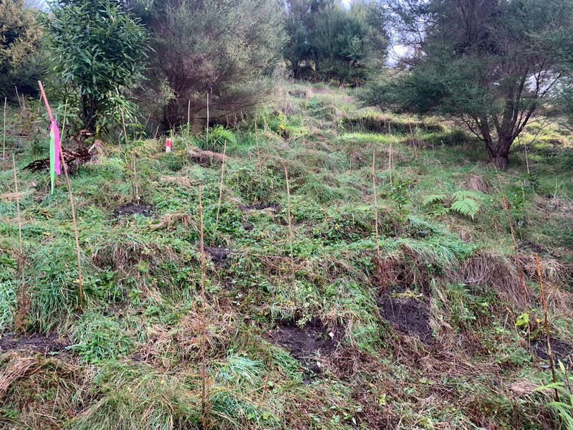

Open exposed plot. Note the increased ground cover of grasses and herb species. These may require controlling to prevent suppression of the planted natives over the next 2-3 years.

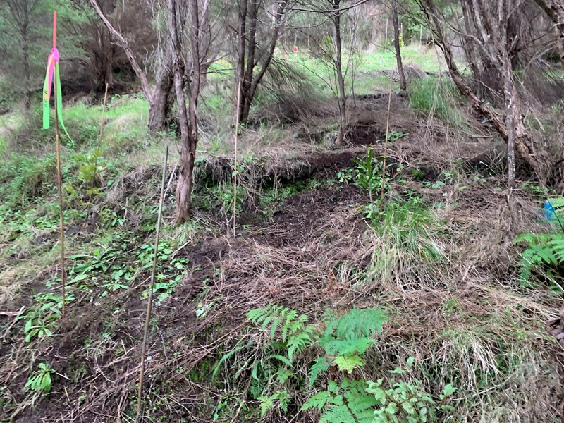

Partially enclosed canopy plot. The bamboo stake with the flagging tape was used to initially identify the plot location before planting and replaced with a permanent wooden peg.

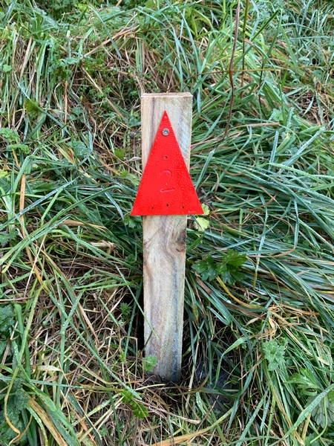 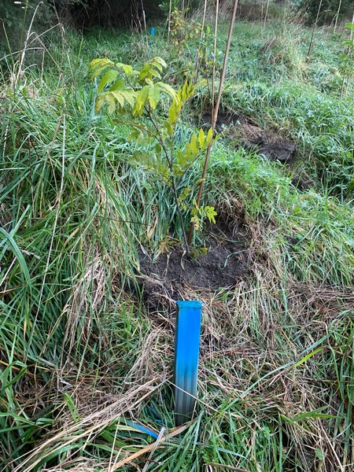

Plot centre peg with the red plastic triangle marker (left), and plot corner peg painted blue (right).

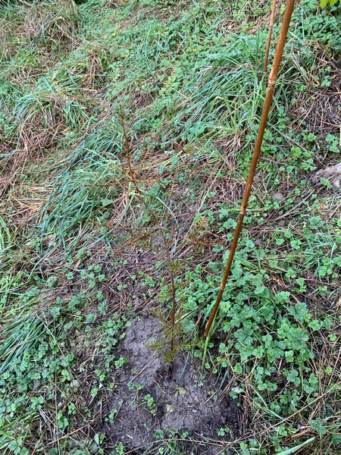 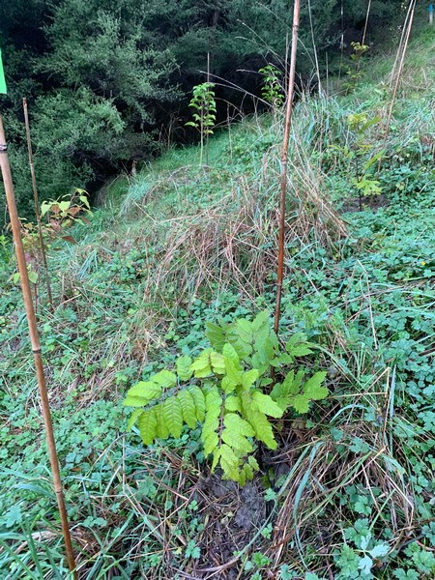

Planted tōtara (left) and titoki (right).

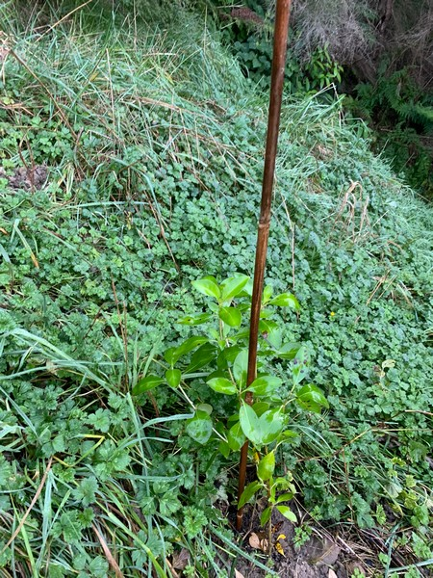 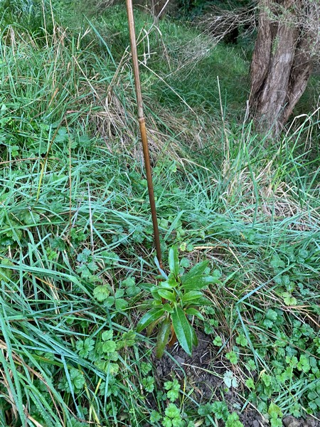

Planted karamu (left) and ngaio (right).

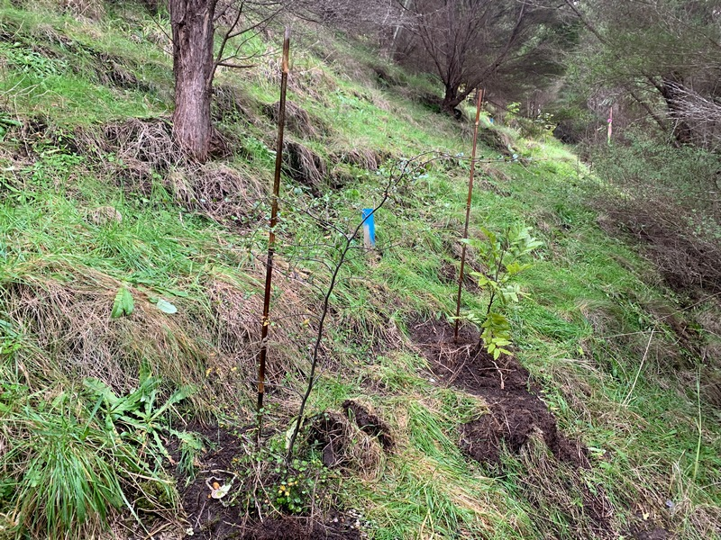

Planted black beech (left) and titoki (right) in a partial shade plot.

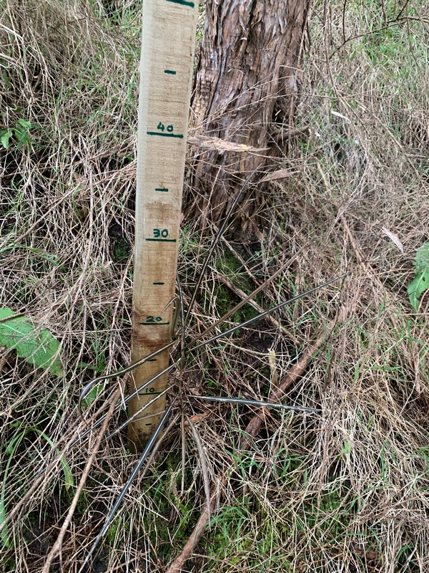 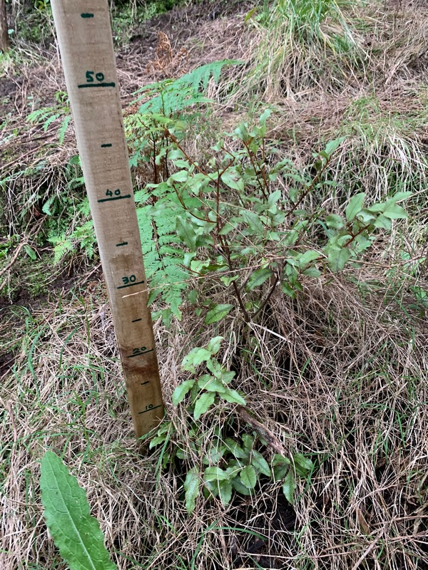

Natural regeneration within some seed island plots – lancewood (left) and māpou and ground fern (right).

## **References**

Bergin, D.; Bergin, M. 2021: Establishment of seed islands to promote regenerating native forest, Waikereru Ecosanctuary, Tairawhiti. Work plan. Tane’s Tree Trust. 14p.

Bergin, M.; Bergin, D. 2022: Evaluation of species and sites for establishing seed islands, Waikereru Ecosanctuary, Tairāwhiti. Tāne’s Tree Trust. 13p.

Bergin, D; Sallis, R.; Kimberley, M.; Bergin, M. 2022: Guide to short-term monitoring of planted natives – field and online methods for measuring early success. Tane’s Tree Trust and Trees That Count. 15p.

Ecoworks New Zealand 2022: Waikereru Seed Islands – Plot Summary pre-plant. Unpublished report. 43p.

Marden, M.; Seymour, A. 2022: Landform mapping of Waikereru Ecosanctuary. Unpublished report produced for the Longbush Ecological Trust. 5p.